NAME: D CHARAN

REG NO.:192211577

**Experiment no:2**

Configuration of tree topology using packet tracer.

### AIM:

Configuration of tree topology using Packet Tracer.

### REQUIREMENTS:

1. End device - They are the devices through which we can pass message from one device to another and they are interconnected.
2. Switch/Hub - Interface Between two devices.
3. Cable - Used to connect two devices.

**Procedure:**

**STEP** 1: Click on end devices, select generic Pc’s drag and drop it on the

window. Click on SWITCH drag and drop it on the window.

**STEP** 2: Select the straight through cable and connect all end device to switch. Assign the IP address for all end devices. (Double click the end device Select →

desktop → IP configuration static)

**STEP** 3: Now set the IP address to Host A (192.168.1.1) in static mode. Similarly set IP address for Host B (192.168.1.2) and Host C (192.168.1.3)

**STEP** 5: To view the IP address, give ipconfig command in command prompt. Using ping command, we can establish communication between two host devices.

**STEP** 6: Now display the packet transmission in simulation mode.

**TREE TOPOLOGY:**

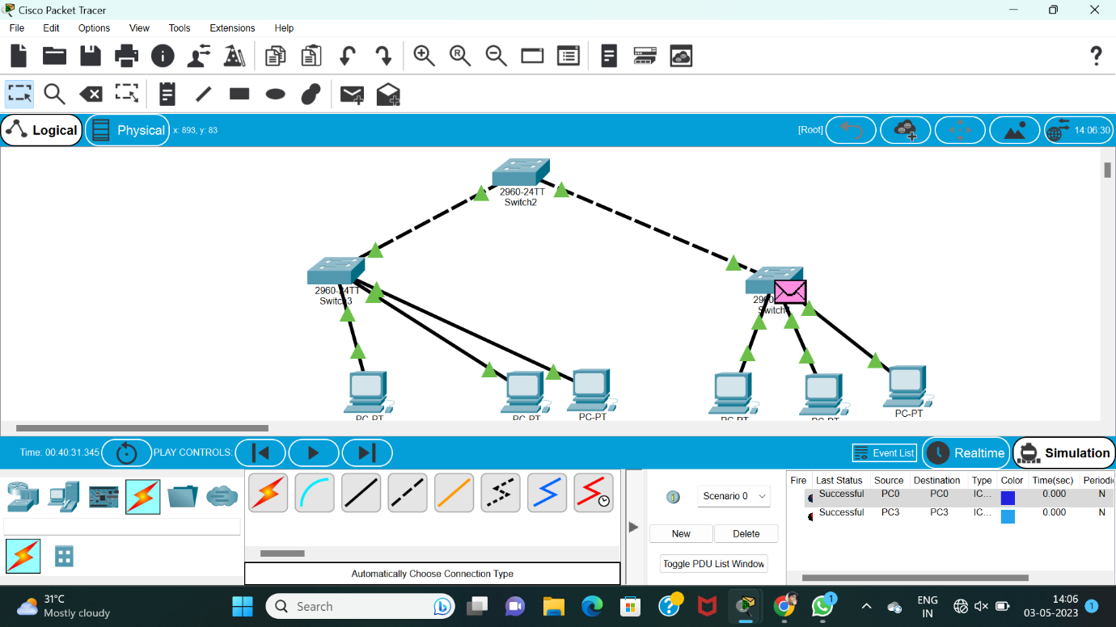

RESULT:

Configuration of TREE Topologies using Packet Tracer communication star is verified successful.